**Pascal Programming Language**

**Research Project:** Older Language- Pascal Programming Language

**Prepared By:** Romit Zunjarrao, Riya Patel, Rohan Naik, Murad Mizanur Rahman

**Project Goal:** Pascal is a general-purpose, high-level language that was originally developed by Nicklaus Wirth in the early 1970s. It was developed for teaching programming as a systematic discipline and to develop reliable and efficient programs.

Pascal is Algol-based language and includes many constructs of Algol. Algol 60 is a subset of Pascal. Pascal offers several data types and programming structures. It is easy to understand and maintain the Pascal programs.

Principle objectives for Pascal were for the language to be efficient to implement and run, allow for the development of well-structured and well organized programs, and to serve as a vehicle for the teaching of the important concepts of computer programming. Pascal, which was named after the mathematician Blaise Pascal, is a direct descendent from ALGOL 60, which Wirth helped develop. Pascal also draws programming components from ALGOL 68 and ALGOL-W.

**Project Description:** Pascal was the primary high-level language used for development in the Apple Lisa, and in the early years of the Mac. In 1986, Apple Computer released the first Object Pascal implementation, and in 1993, the Pascal Standards Committee published an Object-Oriented Extension to Pascal. And also, to learn about Pascal’s importance in depth. Pascal allows the programmers to define complex structured data types and build dynamic and recursive data structures, such as lists, trees and graphs. Pascal offers features like records, enumerations, subranges, dynamically allocated variables with associated pointers and sets.

Pascal allows nested procedure definitions to any level of depth. This truly provides a great programming environment for learning programming as a systematic discipline based on the fundamental concepts.

Among the most amazing implementations of Pascal are −

* Skype
* Total Commander
* TeX
* Macromedia Captivate
* Apple Lisa
* Various PC Games
* Embedded Systems

**Data Types in Pascal:**

* String

Holds Text eg. 'New York', 'Evan‘

* Integer

Holds whole numbers eg 3, 6, 1024

Range :  -32,768 to 32,767

LongInt : -2,147,483,648 to 2,147,487,647

ShortInt : -128 to 128

* Real

Holds Decimal Numbers eg 3.14, 503.2

Range : 2.9 x 10 E-39 to 1.7 x 10 E+38

* Boolean

Holds True or False

* Character

Holds a single character eg. 'A', 'E'

**Output:**

**Pointer in Pascal:**

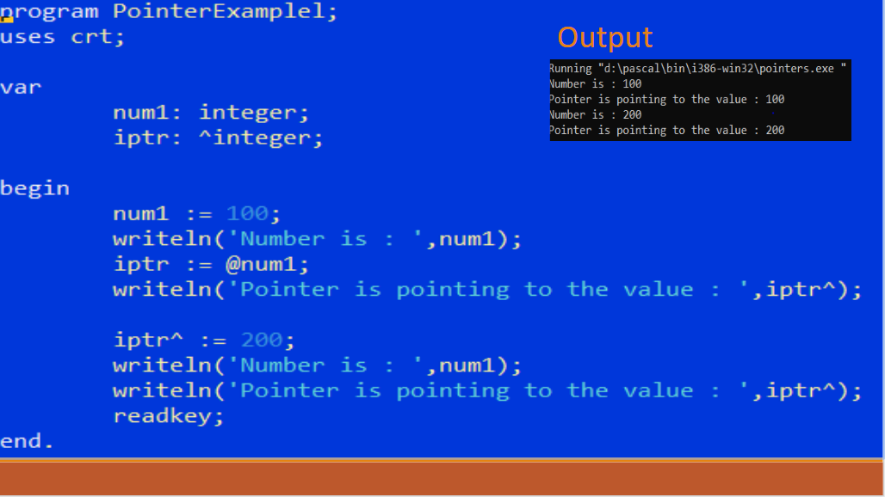

**Data Structure:**

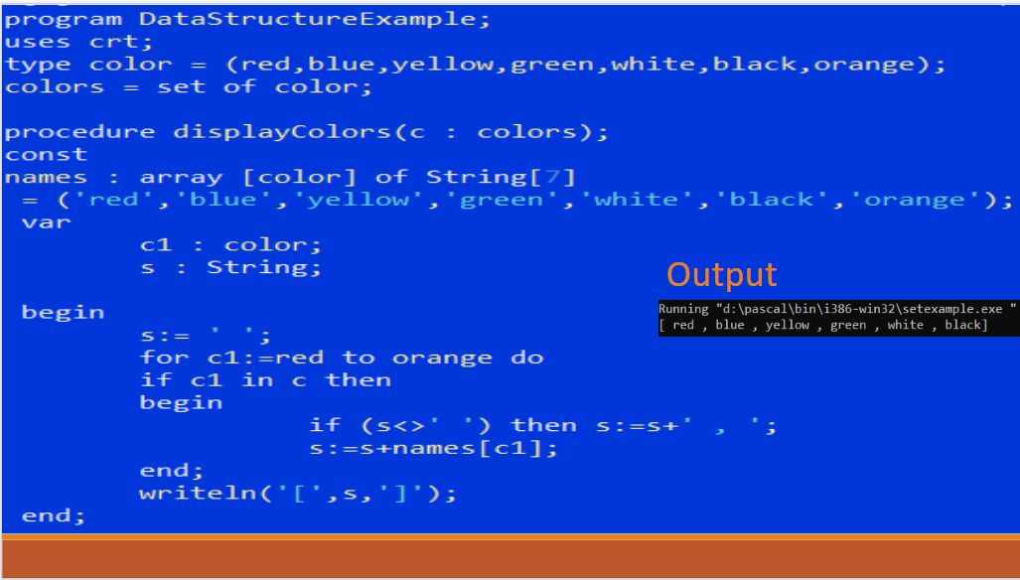

**Conclusion:** Today, Pascal’s been mostly replaced by C, C++ and Java, but it’s still used as an introduction to programming. Used for structured programming, which requires a strong attention to detail, it’s become a popular language to teach new students — however, it’s less popular in the enterprise.

Only 2 percent of businesses said they still support and hire for Pascal — while it’s rare, it also makes anyone with Pascal skills valuable. Software engineers and software developers are the most likely candidates for Pascal skills.

**References:**

<http://groups.umd.umich.edu/cis/course.des/cis400/pascal/pascal.html>

<https://www.tutorialspoint.com/pascal/pascal_overview.htm>

<https://en.wikipedia.org/wiki/Pascal_(programming_language)>